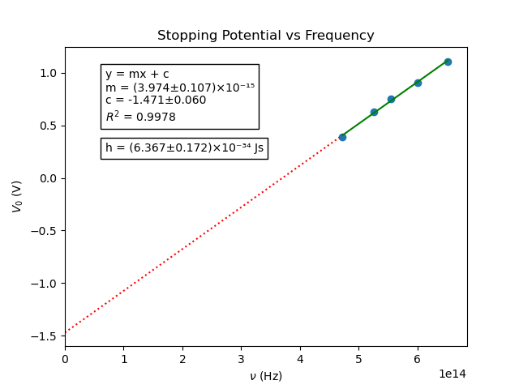
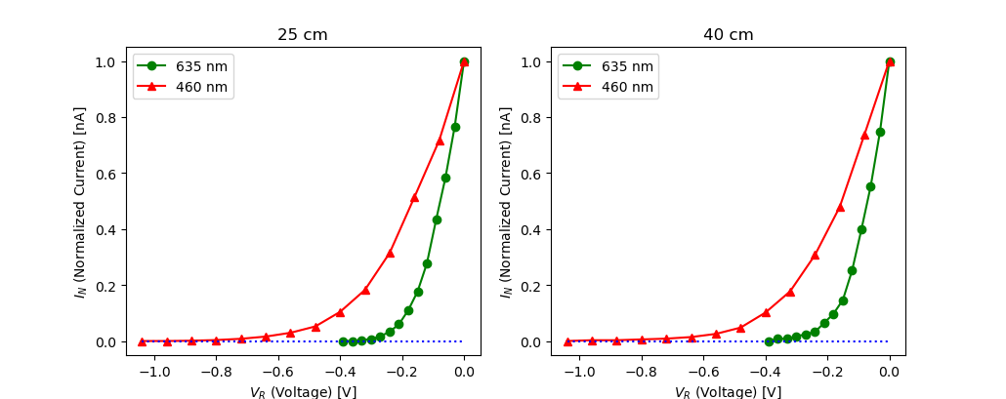

Graph plotted using Python with numpy, scipy and matplotlib

All code can be found on my GitHub profile

Username: TheReconPilot
Repository: IISER-Labs/PHY 222/Photoelectric Effect
Link: https://github.com/TheReconPilot/IISER-Labs/tree/master/PHY%20222/Photoelectric%20Effect

